1] Create a virtual env

2] Install all the modules required to run the task

3] generate a requirements.txt file using “pip freeze > requirements.txt”

4] Create a docker file with necessary configuration

5] Follow these steps…   
a> keep the file structure as it is:

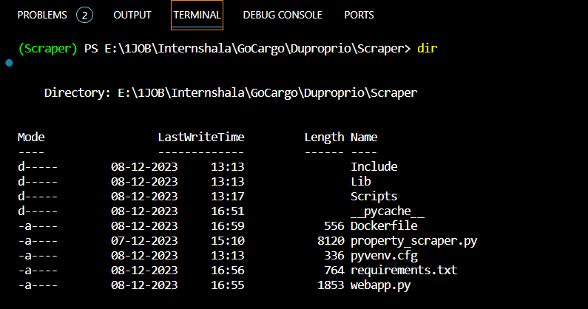

b> Build the container image

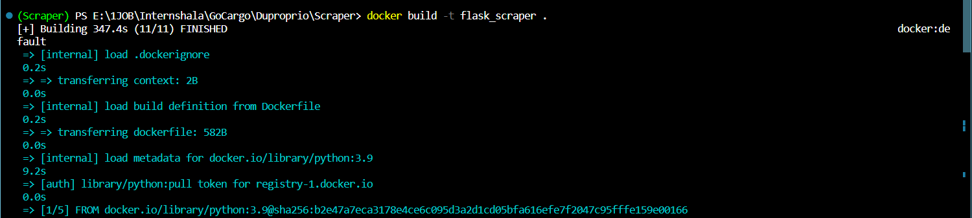

c> To run

